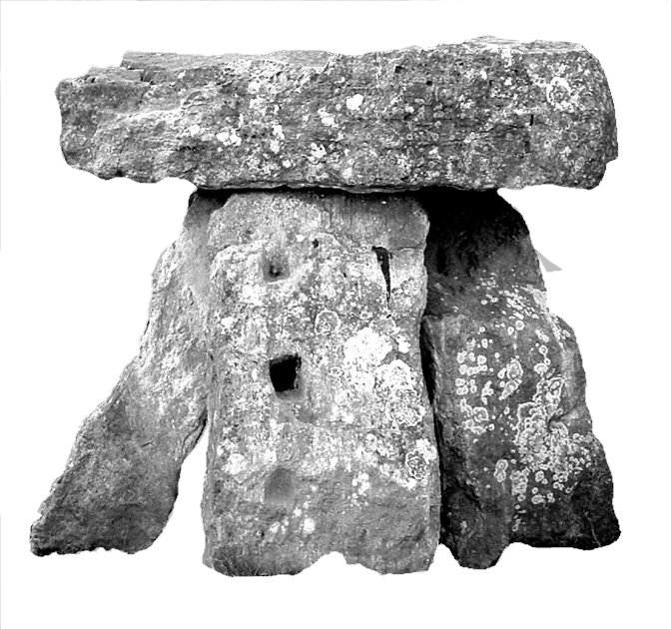
THE THREE SHIRES MEDICAL PRACTICE
Colerne, Marshfield, Pucklechurch and Wick Surgeries

Dr John Seddon Colerne Surgery Tel: (01225) 742028
Dr Richard Greenway Marshfield Surgery Tel: (01225) 891265
Dr Pedro Pinto Pucklechurch Surgery Tel: (0117) 937 2350
Dr Richard Prince Wick Surgery Tel: (0117) 937 2214

ZERO TOLERANCE POLICY

Statement
In line with NHS policy, the Three Shires Medical Practice has a zero tolerance approach to aggression, abuse, violence, hate crimes and hate incidents, or anti-social behaviour towards our staff.
The Practice supports the government's Zero Tolerance campaign for National Health Service Staff. This states that GPs and their staff have a right to care for others without fear of being attacked or abused. To successfully provide these services a mutual respect between all the staff and patients has to be in place. All our staff aim to be polite, helpful, and sensitive to all patients’ individual needs and circumstances. They would respectfully remind patients that very often staff could be confronted with a multitude of varying and sometimes difficult tasks and situations, all at the same time. The staff understand that ill patients do not always act in a reasonable manner and will take this into consideration when trying to deal with a misunderstanding or complaint.
However, aggressive behaviour, be it violent or abusive, will not be tolerated and may result in you being removed from the Practice list and, in extreme cases, the Police being contacted.
In order for the practice to maintain good relations with their patients the practice would like to ask all its patients to read and take note of the occasional types of behaviour that would be found unacceptable:
- Using bad language or swearing at practice staff
- Any physical violence towards any member of the Primary Health Care Team or other patients, such as pushing or shoving
- Verbal abuse towards the staff in any form including verbally insulting the staff
- Racial abuse and sexual harassment will not be tolerated within this practice
- Persistent or unrealistic demands that cause stress to staff will not be accepted. Requests will be met wherever possible and explanations given when they cannot
- Causing damage/stealing from the Practice's premises, staff or patients
- Obtaining drugs and/or medical services fraudulently
We ask you to treat your GPs and their staff courteously at all times.

Removal from the practice list
A good patient-doctor relationship, based on mutual respect and trust, is the cornerstone of good patient care. The removal of patients from our list is an exceptional and rare event and is a last resort in an impaired patient-practice relationship. When trust has irretrievably broken down, it is in the patient’s interest, just as much as that of the practice, that they should find a new practice. An exception to this is on immediate removal on the grounds of violence e.g. when the Police are involved.

Removing other members of the household
In rare cases, however, because of the possible need to visit patients at home it may be necessary to terminate responsibility for other members of the family or the entire household. The prospect of visiting patients where a relative who is no longer a patient of the practice by virtue of their unacceptable behaviour resides, or being regularly confronted by the removed patient, may make it too difficult for the practice to continue to look after the whole family. This is particularly likely where the patient has been removed because of violence or threatening behaviour and keeping the other family members could put doctors or their staff at risk.

Three Shires Medical Practice
9/2021

